**Session 2**

### **1. Import the Video Game Sales.csv-** [**CSV File**](https://drive.google.com/file/d/1xAOLqziBMK6RkBkCu69rXXd5DvvsOGvU/view?usp=share_link)

### 

### **2. After importing, in Column "JP_Sales", create Traffic Light Conditional Formatting.**

**Rules:** **Any value > 10, should be Green Any value >=5 and <=10 should be Orange Any value <5 should be Red**

**Output as shown in the image below:**

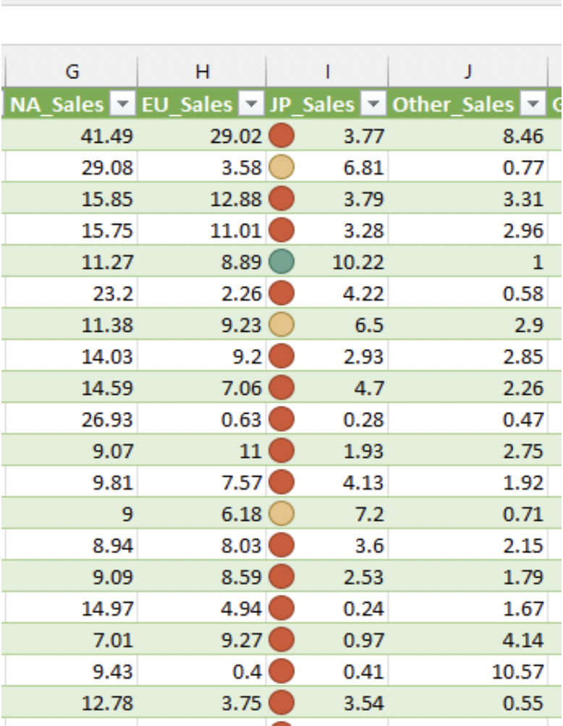

### 

### **3. After importing, in Column J, "JP_Sales", create Data Bars Conditional Formatting:**

**A. Change the value of the cell J5 to -2.8   
B. Set the minimum value as 0% and the Maximum as 100%   
C. Set the bar appearance as Gradient Fill   
D. Set the color as "Orange Accent 2, Darker 25%". If you take your mouse cursor over the color, you can see the name of the color.   
E. Set the negative Value color as "Gold Accent 4"   
F. Set the Axis settings as "Cell midpoint"   
G: Set Axis color as Red.**

**Output as shown in the image below:**

